WINSTON-SALEM’S REYNOLDS AUDITORIUM UPGRADES ITS WIRELESS microphone system WITH SENNHEISER DIGITAL 6000

Winston-Salem, NC, April 9, 2018 – Reynolds Auditorium has played host to well-regarded touring acts, from the Moscow Ballet to Sweet Honey in the Rock to the National Black Theater Festival. All the while, located on the campus of an area high school, community-centered productions are also a significant part of its oeuvre. These include everything from high school theater productions to a cappella performances. When it came time to upgrade Reynolds Auditorium’s wireless microphone capabilities, manager Liz May saw an opportunity to better accommodate performers of every level with Sennheiser’s cutting-edge Digital 6000 wireless system.

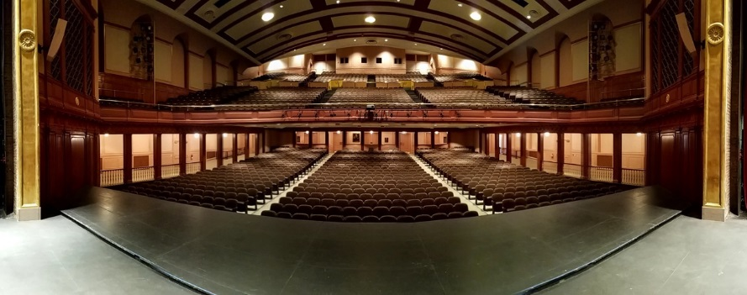 | Reynolds Auditorium located in Winston-Salem, NC, plays host to both national and international touring acts as well as local performances. Recently, it acquired a Sennheiser Digital 6000 wireless system.

The Future Has Arrived
The decision to upgrade the Reynolds Auditorium’s old wireless equipment was easy—a significant part of its wireless system had been recently rendered out of FCC compliance. “12 of our existing 23 channels were no longer operable after the latest FCC frequency band auctions,” said May. “It was pretty significant.” Having recently encountered Sennheiser’s wireless systems at one of the company’s events in Germany, she arranged for samples of Sennheiser products to test on-site.

May conducted a shootout of products from several manufacturers, including the Digital 6000, utilizing the local a cappella group as her sound source. She chose to purchase two channels of Digital 6000 wireless and an additional four channels of G3 wireless, providing a solid foundation for national touring acts and aspiring thespians alike.

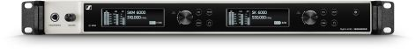 | The dual-channel EM 6000 DANTE receiver for the Sennheiser Digital 6000 wireless system.

Wireless That’s Worthy
For May, having two channels of pristine Digital 6000 wireless ensures that she has the quality she needs to handle some of the high-level touring acts that come through the auditorium. “We don’t do many productions where we necessarily need 24 channels of the highest-quality mics, but we do quite a few productions where I need a couple of high-quality channels for soloists or the like, and that’s where the Digital 6000 comes in,” she said. The added fidelity helps the most important elements of the mix stand out from the pack. “We have a competitive a cappella program here and we do three a cappella competitions throughout the year, so one of the nice things is putting the Digital 6000 mics on the soloists to pull them out of the mix even with 20 other voices on stage,” she explained.

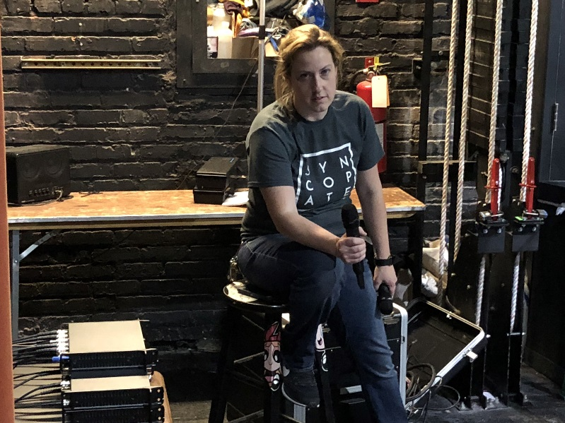 | Manager Liz May conducted a shootout of products from several manufacturers, utilizing the local a cappella group as her sound source. She chose to purchase two channels of Digital 6000 wireless and an additional four channels of G3 wireless.

The Digital 6000 also helped mitigate the effects of some of the less flattering acoustic characteristics of the century-old hall. “Compared to other mics we’ve owned, the Digital 6000 has amazing clarity on the top end that works really well in our space. Our facility was built in the 1920s, so it’s got old architecture with big halls and a lot of muddy sound characteristics. The Digital 6000 cuts through really well given the situation. The fact that it’s digital seems to allow it to retain that extra clarity that might otherwise be lost in transmission.”
Digital Convenience
In addition to its notable sonic characteristics, the Digital 6000 makes frequency coordination a snap for May. “One nice thing about the 6000 is that it is very spectrally efficient,” she said. “Because we have so many wireless mics going at once, we’re getting pretty crunched for frequency space, so the Digital 6000 gives us some extra wiggle room.” But the frequency efficiency isn’t the only cutting-edge feature May takes advantage of. “We’re on a Dante system here, so it’s great having the Dante connection right on the EM 6000,” May says. “I use up 12 inputs on my stage box by default for my other mics, so with the Dante outputs I can just patch the Digital 6000’s channels wherever I want and keep those other inputs open.”

May acquired a pair each of SKM 6000 handheld and SK 6000 bodypack transmitters to ensure she had the perfect tool for any performance, be it theater or music. The SKM 6000 transmitters, which she pairs with Sennheiser’s MD 9235 capsule, have helped key vocals stand out while mitigating feedback. “It’s a good versatile capsule,” May said. “We can use them on the podium when we have speakers and it picks them up well and does a nice job with proximity effect. We also have an apron that sticks out past where our PA starts, so rejection is pretty key when we’re using that. We’ve definitely had fewer issues with feedback with the Digital 6000 than we did with past systems.”

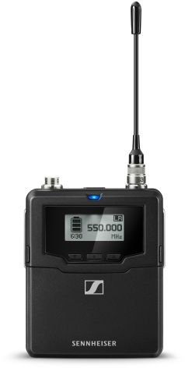 | Reynolds Auditorium staff love the compact, rugged metal chassis of the Sennheiser SK 6000 bodypack transmitter. Durable enough to endure frequent usage and small enough to be hidden out of sight in a performer’s costume, the SK 6000 delivers a pristine digital audio signal as part of the Digital 6000 wireless system.

Hidden Strength
The SK 6000 bodypacks, paired with Sennheiser’s MKE 2 lapel mics, give May the versatility she needs for theatrical productions. “The SK 6000 bodypacks are a lot lighter and more compact than others we’ve used, and that’s been really helpful for the musicals that we do where you have to conceal everything pretty well. The MKE 2 lapel mics are really tiny, too, making them pretty invisible.” She also appreciates the SK 6000’s rugged housing, which can stand up to the demands of a multi-use theatre space. “Durability is a big factor because we deal with so many school productions,” she said. “The bodypack housing and the mics themselves can withstand the abuse they may get from our in-house events and still be good to go for our national touring acts.”

The SKM 6000 and SK 6000 transmitters have also made reliable power easier with their long-lasting rechargeable battery packs. “We used to go through a ton of batteries when we do our a cappella competitions, but the rechargeable batteries last as long, if not longer, than disposable batteries did on our old system.”

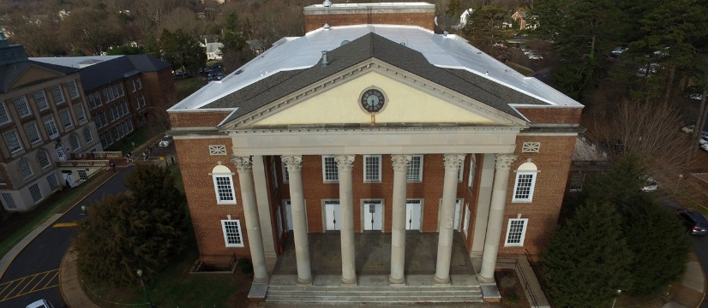 | The Digital 6000 has enabled the Reynolds Auditorium to present itself as a welcoming environment for top level touring acts that require uncompromising professional audio.

For May and the Reynolds Auditorium team, the Digital 6000 is about more than great sound: it also helps increase their profile as a high-quality venue that can host national and international acts in Winston-Salem. “We’re constantly trying to make sure we have equipment and technology that meets the requirements of touring groups and big musical acts,” said May. “Having gear like the Digital 6000 in house opens doors for us.” Pleased with their purchase, May intends to acquire two more channels of Digital 6000 wireless as soon as possible. “It’s such a flexible platform,” she said. “It’s nice to know that we can even get another capsule set to increase our options down the road. The Digital 6000 is doing great things for us.”

About Sennheiser
Sennheiser is shaping the future of audio – a vision built on more than 70 years of innovation culture, which is deeply rooted within the family-owned company. Founded in 1945, Sennheiser is one of the world’s leading manufacturers of headphones, microphones and wireless transmission systems. With 20 sales subsidiaries and long-established trading partners, the company is active in more than 50 countries and operates its own production facilities in Germany, Ireland and the USA. Sennheiser has around 2,800 employees around the world that share a passion for audio excellence. Since 2013, Sennheiser has been managed by Daniel Sennheiser and Dr. Andreas Sennheiser, the third generation of the family to run the company. In 2016, the Sennheiser Group had sales totaling €658.4 million. www.sennheiser.com

Local Contact Global Contact

Jeff Touzeau Stephanie Schmidt
jeff@hummingbirdmedia.com stephanie.schmidt@sennheiser.com
+1 (914) 602-2913 +49 (5130) 600 – 1275

